CALL FOR PAPERS
Special Session on “Please add here the Title of the special session...............................”
2026 8th International Conference on Image, Video and Signal Processing (IVSP 2026)
March 17-19, 2026 in Meiji University Surugadai Campus, Tokyo, Japan
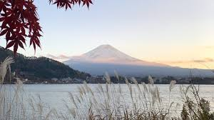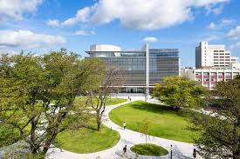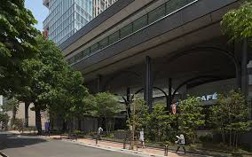
ORGANIZED AND CHAIRED by
Organizer 1 name and affiliation
Email address
Organizer 2 name and affiliation
Email address

SPECIAL SESSION DESCRIPTION (no more than 150 words)

Please add a short description of the topic

TOPICS COVERED (no more than 5)
- Topic 1
- Topic 2
- Topic 3
- Topic 4
- Topic 5

Supported by:

Published by:
Indexed by:
 

